**Homework 1**

**Medical Image Computing**



**Name: Qazi Danish Ayub MSDS20075**

**The following applications, download and use it.**

• ImageJ

**ScreenShot of the GUI**

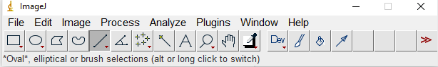

**Short Findings about ImageJ**

A software application with the simplest user interface that helps you to handle the images of any type and provide almost all the basic functionalities like Smooth, sharpen find edges Find Maxima enhancing the contrast noise shadows binary math FFT and filters batch image calculator subtract background similarly you can measure distances between specific points as well as analyse the particles in an image and many more functionalities.

**Explain how you can use it and how it works.**

You can simply get sample images

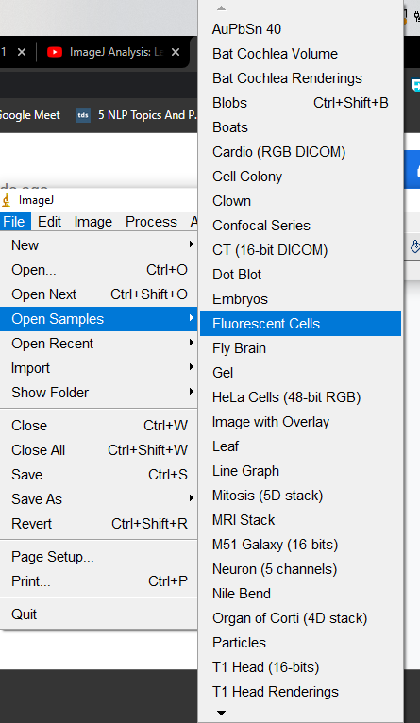

Or you can load your own image and perform basic operations like smoothing or binary conversion of the image. Plus calculate the distance between any points in the image and find the mean of your findings. Plus many more things that I have explored but can not sum up all of those tried filters on the image changed the size dimension of the image plus converted the image to different scales.

**You have to load some images in the applications and see how you can process them.**

All the process was done on two images one was of the clown and the other was of the heart image both taken from the samples images in the ImageJ software. The process was explained in the short description about the software. But for ease almost most of the functionality is covered by the process drop down options and the analyzer gives you all the functionalities of measuring the processes.